Project Design Phase-II
Data Flow Diagram & User Stories

Date | 30 September 2026
Team ID | SWTID-2026-8376
Project Name | AI Weather Wise API
Maximum Marks | 4 Marks

Data Flow Diagrams:
A Data Flow Diagram (DFD) is a traditional visual representation of the information flows within a system. A neat and clear DFD can depict the right amount of the system requirement graphically. It shows how data enters and leaves the system, what changes the information, and where data is stored.

AI WeatherWise API DFD Level 0 Context
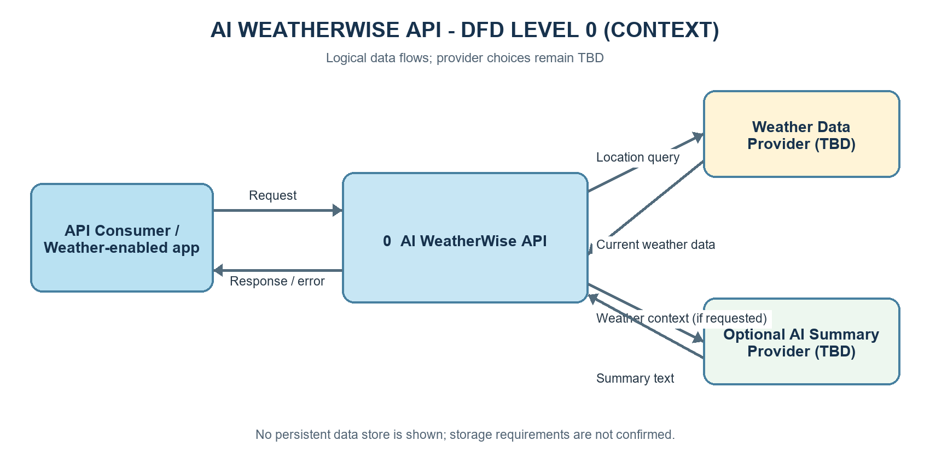
AI WeatherWise API DFD Level 1 Request Processing
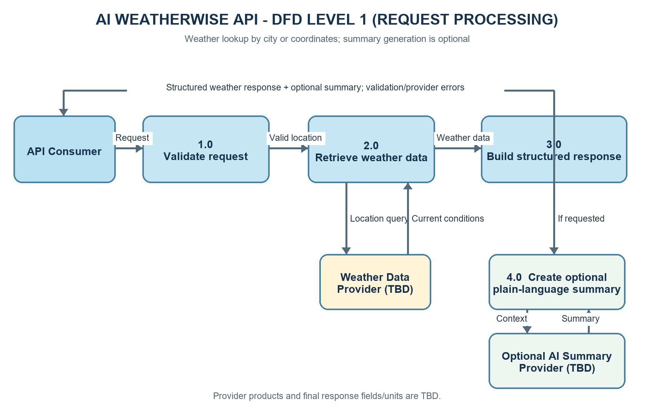
User Stories
Use the below template to list all the user stories for the product.
User Type | Functional Requirement (Epic) | User Story Number | User Story / Task | Acceptance criteria | Priority | Release
API Consumer | Weather lookup | USN-1 | As an API consumer, I want current weather by city so that an app can show local conditions. | A valid city request returns current weather data for the resolved location. | High | Sprint-1
API Consumer | Weather lookup | USN-2 | As an API consumer, I want current weather by coordinates so that an app can request a precise location. | Valid latitude and longitude return current weather data for that location. | High | Sprint-1
API Consumer | Weather lookup | USN-3 | As an API consumer, I want a consistent response structure so that my app can process weather results. | The response follows the published schema and documents its fields and units; exact schema is TBD. | High | Sprint-1
API Consumer | Input and reliability | USN-4 | As an API consumer, I want clear validation errors so that I can correct a missing or invalid location. | Missing or invalid location returns a clear client error and does not expose internal details. | High | Sprint-2
API Consumer | Input and reliability | USN-5 | As an API consumer, I want a controlled response when the weather provider is unavailable so that my app can handle the failure. | Timeout or provider failure returns a documented error without exposing credentials or internal details. | Medium | Sprint-2
API Consumer | Optional AI summary | USN-6 | As an API consumer, I want to request an optional plain-language summary so that weather information is easier to understand. | When requested and available, a plain-language summary accompanies the structured weather data. | Medium | Sprint-3
API Consumer | Optional AI summary | USN-7 | As an API consumer, I want weather data even if summary generation fails so that the core feature remains useful. | If summary generation fails, core weather data is returned and summary availability is clearly indicated. | Medium | Sprint-3
API Consumer | Integration and release | USN-8 | As an API consumer, I want usage documentation so that I can integrate and interpret the API correctly. | Documentation explains request inputs, response schema and units, errors, and optional-summary behavior; planned UAT scenarios pass before release. | High | Sprint-4

